Sandra Schmöckel

King Abdullah University of Science and Technology
Saudi Arabia

The genome of Chenopodium quinoa provides insights into saponin biosynthesis and salinity tolerance mechanisms

Thursday, September 14, 14.00, Seminar Room B2

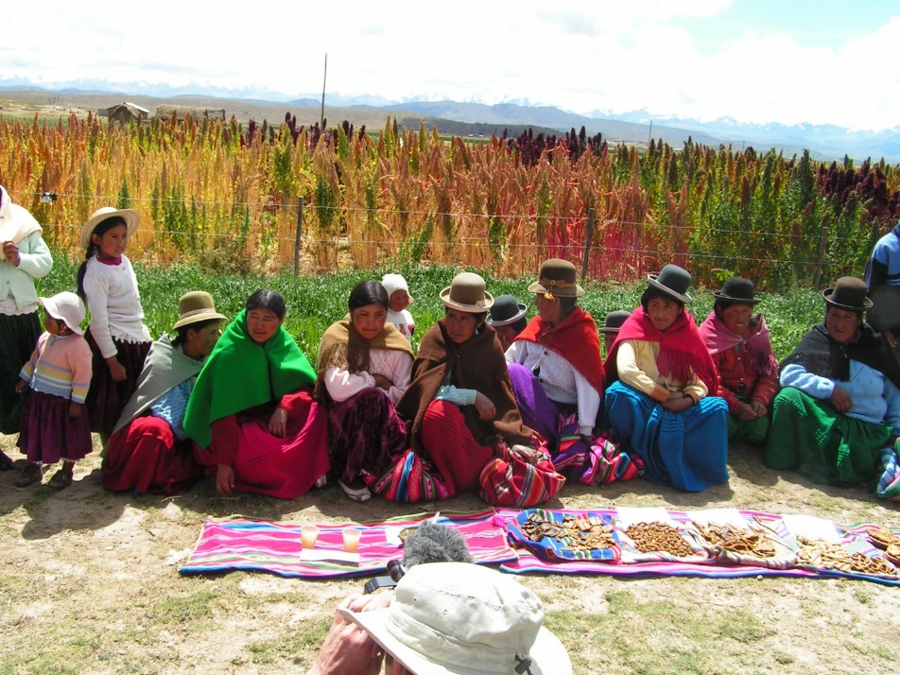
Chenopodium quinoa (quinoa) is a highly nutritious grain crop identified as an important crop to improve world food security; unfortunately, few resources are available to facilitate its genetic improvement. The assembly of a high-quality, chromosome-scale reference genome sequence for quinoa was produced using single-molecule real-time sequencing in combination with optical, chromosome contact, and genetic maps. We also report the sequencing of two diploids from the ancestral gene pools of quinoa – which enabled the identification of sub-genomes in quinoa – and reduced-coverage genome sequences for 22 other accessions of the allotetraploid goosefoot complex. The genome sequence facilitated the identification of the transcription factor likely to control the production of anti-nutritional triterpenoid saponins found in quinoa seeds, including a mutation that appears to cause alternative splicing and a premature stop codon in sweet quinoa accessions. By integrating physiological data with RNAseq and SNP analyses we are also starting to unravel salinity tolerance mechanisms in quinoa.

Kontakt: Helena Štorchová

